1- TestNG as dependency, plugin

Assignment number 10 or any prev assignment

Convert that into testng test

Create testng.xml

Run complete test in all 3 browser in seq mode

Run complete test in all 3 browser in parallel mode

Note- Assert in all test

BeforeMethod BeforeClass (Optional)

Share the html report

package assignment12;

import java.time.Duration;

import java.util.List;

import org.openqa.selenium.By;

import org.openqa.selenium.JavascriptExecutor;

import org.openqa.selenium.WebDriver;

import org.openqa.selenium.WebElement;

import org.openqa.selenium.chrome.ChromeDriver;

import org.openqa.selenium.edge.EdgeDriver;

import org.openqa.selenium.firefox.FirefoxDriver;

import org.openqa.selenium.interactions.Actions;

import org.testng.Assert;

import org.testng.Reporter;

import org.testng.annotations.AfterClass;

import org.testng.annotations.BeforeClass;

import org.testng.annotations.Parameters;

import org.testng.annotations.Test;

import helper.Utility;

public class TaskInTestNG {

WebDriver driver;

@Parameters("browser")

@BeforeClass

public void launchBrowser(String browserName) {

if (browserName.equalsIgnoreCase("chrome")) {

driver = new ChromeDriver();

} else if (browserName.equalsIgnoreCase("firefox")) {

driver = new FirefoxDriver();

} else if (browserName.equalsIgnoreCase("edge")) {

driver = new EdgeDriver();

}

driver.manage().window().maximize();

driver.manage().timeouts().pageLoadTimeout(Duration.ofSeconds(10));

driver.get("https://ineuron-courses.vercel.app/login");

driver.manage().timeouts().implicitlyWait(Duration.ofSeconds(10));

}

@AfterClass

public void closeBrowser() {

driver.quit();

}

@Parameters("getCourse")

@Test

public void testOne(String enterCourseName) {

driver.findElement(By.id("email1")).sendKeys("ineuron@ineuron.ai");

driver.findElement(By.id("password1")).sendKeys("ineuron");

driver.findElement(By.xpath("//button[text()='Sign in']")).click();

// Thread.sleep(3000);

WebElement manageText = driver.findElement(By.xpath("//span[text()='Manage']"));

Actions action = new Actions(driver);

action.moveToElement(manageText).perform();

driver.findElement(By.xpath("//span[text()='Manage Courses']")).click();

WebElement manageCourseText = driver.findElement(By.xpath("//h1[text()='Manage Courses']"));

Reporter.log(manageCourseText.getText(), true);

action.moveToElement(manageCourseText).perform();

driver.findElement(By.xpath("//button[text()='Add New Course ']")).click();

driver.findElement(By.id("thumbnail")).sendKeys("C:\\Users\\ashu2\\OneDrive\\Desktop\\abc\\imgae1.png");

WebElement courseName = driver.findElement(By.xpath("//input[@id='name']"));

courseName.sendKeys(enterCourseName);

WebElement descriptionText = driver.findElement(By.id("description"));

descriptionText.sendKeys("I am Learning Java Selenium with Mukesh Otwani");

WebElement instructorName = driver.findElement(By.name("instructorName"));

instructorName.sendKeys("Mukesh Otwani");

WebElement coursePrice = driver.findElement(By.id("price"));

coursePrice.sendKeys("5000");

WebElement startDate = driver.findElement(By.name("startDate"));

startDate.click();

List<WebElement> allStartDates = driver

.findElements(By.xpath("//div[@role='listbox']//div[@aria-disabled='false']"));

for (WebElement strtDate : allStartDates) {

if (strtDate.getText().equals("22")) {

strtDate.click();

break;

}

}

WebElement endDate = driver.findElement(By.name("endDate"));

endDate.click();

List<WebElement> allEndDates = driver

.findElements(By.xpath("//div[@role='listbox']//div[contains(@aria-label,'January')]"));

for (WebElement lastDate : allEndDates) {

if (lastDate.getText().equals("28")) {

lastDate.click();

break;

}

}

driver.findElement(By.xpath("//div[text()='Select Category']")).click();

List<WebElement> listCategories = driver.findElements(By.xpath("//div[contains(@class,'menu-items')]/button"));

for (WebElement list : listCategories) {

if (list.getText().equals("Testing")) {

list.click();

break;

}

}

driver.findElement(By.xpath("//button[text()='Save']")).click();

Utility.waitForSeconds(3);

List<WebElement> courseList = driver.findElements(By.xpath("//tbody//td[2]"));

boolean isPresent = false;

for (WebElement ele1 : courseList) {

if (ele1.getText().equals(enterCourseName)) {

String course = ele1.getText();

isPresent = driver.findElement(By.xpath("//td[text()='"+course+"']")).isDisplayed();

isPresent = true;

break;

}

}

Assert.assertTrue(isPresent, "Course is not present");

for (WebElement ele : courseList) {

if (ele.getText().equals(enterCourseName)) {

String course = ele.getText();

Reporter.log("Course is Added.." + course, true);

WebElement check = driver

.findElement(By.xpath("//td[text()='" + course + "']/preceding-sibling::td/input"));

action.doubleClick(check).build().perform();

WebElement deleteBtn = driver.findElement(By.xpath("//td[text()='" + course

+ "']/preceding-sibling::td/input/parent::td//following-sibling::td/button"));

JavascriptExecutor js = (JavascriptExecutor) driver;

try {

deleteBtn.click();

} catch (Exception e) {

System.out.println("Webelement is not clickable delete using javascript");

js.executeScript("documents[0].click()", deleteBtn);

}

// Thread.sleep(3000);

Utility.waitForSeconds(3);

break;

}

}

List<WebElement> courseList1 = driver.findElements(By.xpath("//tbody//td[2]"));

boolean isPresentAfterDelete =false;

for (WebElement ele1 : courseList1) {

if (ele1.getText().equals(enterCourseName)) {

String course = ele1.getText();

isPresentAfterDelete = driver.findElement(By.xpath("//td[text()='"+course+"']")).isDisplayed();

isPresentAfterDelete = true;

break;

}

}

Assert.assertFalse(isPresentAfterDelete, "Course is not deleted yet..");

Utility.waitForSeconds(3);

driver.findElement(By.xpath("//button[normalize-space()='Sign out']")).click();

Utility.waitForSeconds(3);

}

}

**Run complete test in all 3 browser in seq mode**

<?xml version="1.0" encoding="UTF-8"?>

<!DOCTYPE suite SYSTEM "https://testng.org/testng-1.0.dtd">

<suite name="Automation in sequential">

<test name="Test on chrome">

<parameter name="browser" value="chrome"></parameter>

<parameter name="getCourse" value="Automation using Selenium"></parameter>

<classes>

<class name="assignment12.TaskInTestNG"/>

</classes>

</test> <!-- Test -->

<test name="Test on fire fox">

<parameter name="browser" value="firefox"></parameter>

<parameter name="getCourse" value="Automation using Python"></parameter>

<classes>

<class name="assignment12.TaskInTestNG"/>

</classes>

</test> <!-- Test -->

<test name="Test on edge">

<parameter name="browser" value="edge"></parameter>

<parameter name="getCourse" value="Automation using JavaScript"></parameter>

<classes>

<class name="assignment12.TaskInTestNG"/>

</classes>

</test> <!-- Test -->

</suite> <!-- Suite -->

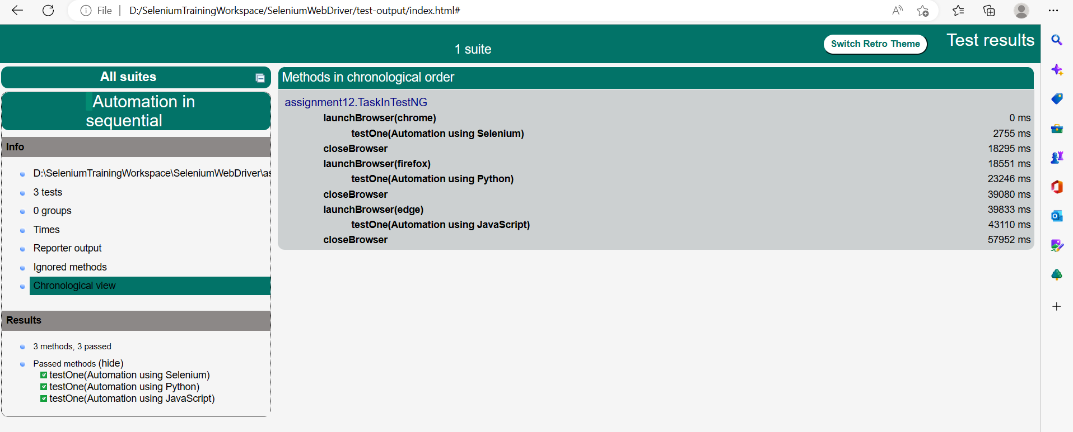

TestNG reports

**Run complete test in all 3 browser in parallel mode**

<?xml version="1.0" encoding="UTF-8"?>

<!DOCTYPE suite SYSTEM "https://testng.org/testng-1.0.dtd">

<suite name="Automation in parallel" parallel="tests" thread-count="3">

<test name="Test on chrome">

<parameter name="browser" value="chrome"></parameter>

<parameter name="getCourse" value="Automation using Selenium"></parameter>

<classes>

<class name="assignment12.TaskInTestNG"/>

</classes>

</test> <!-- Test -->

<test name="Test on fire fox">

<parameter name="browser" value="firefox"></parameter>

<parameter name="getCourse" value="Automation using Python"></parameter>

<classes>

<class name="assignment12.TaskInTestNG"/>

</classes>

</test> <!-- Test -->

<test name="Test on edge">

<parameter name="browser" value="edge"></parameter>

<parameter name="getCourse" value="Automation using JavaScript"></parameter>

<classes>

<class name="assignment12.TaskInTestNG"/>

</classes>

</test> <!-- Test -->

</suite> <!-- Suite -->

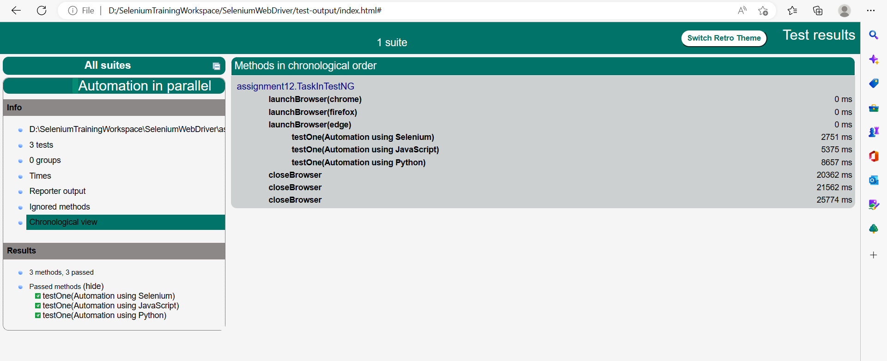

TestNG reports